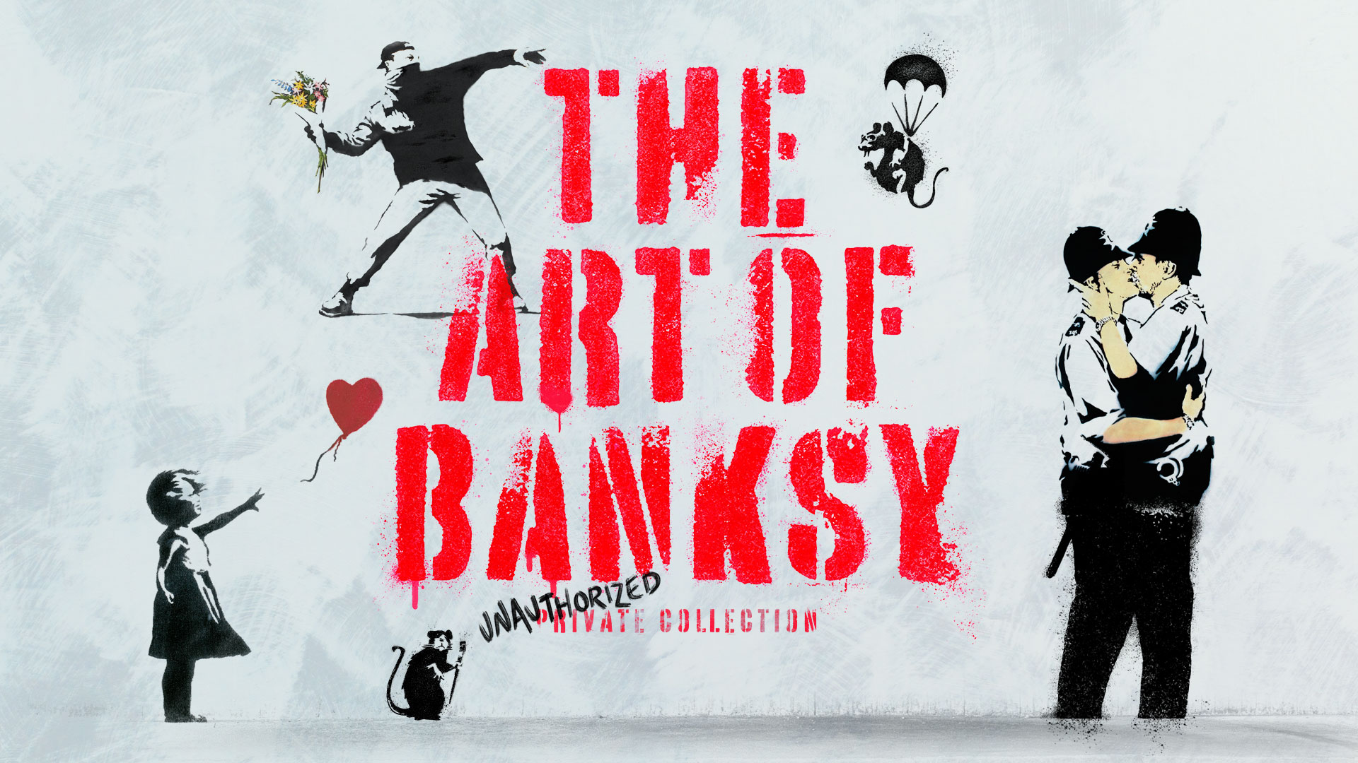

*STRICTLY EMBARGOED UNTIL 9AM THURSDAY 15 SEPTEMBER 2022*
Blockbuster exhibition The Art of Banksy announces opening at MediaCity Salford

Press View 20 October
Friday 21 October 2022 – Sunday 8 January 2023

Tickets from £19.50, concessions available

Presented in association with HOME
Following a successful year-long run in London and critical acclaim around the world, The Art of Banksy has announced its opening at MediaCity on 21 October 2022. This blockbuster exhibition has gathered 145 iconic pieces from private collections across the globe to create the world’s largest touring collection of authenticated and unique Banksy artworks.

Having travelled to Melbourne, Chicago, San Francisco, Sydney, Washington DC, Boston, Tel Aviv, Auckland, Toronto, Miami, Gothenburg and London, The Art of Banksy now gives the North of England the chance to experience the infamous artist’s most well-known works, alongside those rarely seen by the public, all on loan from private collectors.

The Art of Banksy, presented in association with HOME, will feature 145 authenticated Banksy works ranging from prints, canvases, limited-edition pieces, unique works and fascinating ephemera. It represents a rare opportunity to see an overview of Banksy’s work from 2002 to 2017 in a purpose-built 1,200 square metre temporary structure in the heart of MediaCity, offering visitors the chance to view the artist’s work in a way not possible on the street or in any museum or gallery.

Visitors can see the iconic artworks that brought the anonymous artist international acclaim, including Girl With Balloon (2002) in three different colour variations, Flower Thrower (2003), Rude Copper (2002), and Brace Yourself (2010) – a work which made headlines when Banksy gifted the painting to the band formerly known as ‘Exit Through the Gift Shop’ in exchange for the rights to their name.

A recent poll ranked Girl with Balloon as the United Kingdom's favourite piece of artwork while Time Magazine has previously included Banksy in its list of the world’s 100 most influential people alongside Barack Obama, Stella McCartney and Steve Jobs. The iconoclastic artist’s history of pranks has also contributed to this reputation; they have performed powerful statement acts such as the secret installation of a shredder into Girl With Balloon to make the work self-destruct just moments after it was sold at auction for nearly $1.4 million 2018, transforming the work into Love in the Bin.

The Art of Banksy is an exhibition for all ages - an unmissable show for culture lovers and indeed anyone who wants to learn more about the artist and what their work reveals today; the power of art to affect social change, inspire the public and lay bare the undercurrents of social issues with understated wit.

The Art of Banksy is produced by GTP Exhibitions Ltd. The MediaCity season is presented by The Art of Banksy Touring Ltd in association with HOME. The exhibition is not curated or authorized by Banksy.

www.artofbanksy.co.uk

Notes to Editors:

Exhibition Title: The Art of Banksy

Location: The Art of Banksy
The Piazza
MediaCity
Salford Quays
M50 2HF

Ticketing: Tickets are priced from £19.50 (concessions available) and can be booked online at artofbanksy.co.uk or over the phone, on 0343 208 1838

Website: www.artofbanksy.co.uk
Instagram: @artofbanksyexhibit

For all enquiries, high-res images and further information contact Carousel:

Lauren Morgan, James Lennon:
0161 302 0206
Lauren.morgan@carouselpr.com
James.lennon@carouselpr.com
www.carouselpr.com

